Current Operable Unit 3 Remedial Progress for Week Ending 1/8/10
Creamer Environmental Inc., National Grid’s Remediation Contractor, has started the excavation and backfill tasks where the LIRR tracks were relocated. To date 76 trucks have transported approximately 2072.62 tons (1381.75 cubic yards) of soil to Bay Shore Soil Management (formerly ESMI of NJ) for thermal desorption. Additionally 22,030 gallons of impacted excavation water has be disposed of at Clean Waters of Staten Island and Bridgeport United Recycling in Connecticut
GEI, National Grid’s Remediation Oversight Consultant, continues to perform CAMP (Community Air Monitoring Program), Noise and Vibration monitoring. CAMP, Noise and Vibration monitoring will continue throughout the project.

Two-Week Outlook
Phase 1 sheet pile installation and construction is nearly complete. Excavation of cells numbered 3 thru 7 have been partially excavated to allow final installation of the shoring support system. All structural support members are in place and final welding is anticipated to be completed by the middle of the week ending January 15. Full scale excavation and load out of impacted soil will restart in the early part of the week ending January 15. The back filling and restoration phases of the project will commence immediately after each individual cell is excavated to design depth. Phase 1 is anticipated to continue until late January or mid February.
General hours of operation will continue to be Monday through Friday, 7:00 AM to 3:30 PM. However, work hours will be extended when necessary to maintain schedule or to complete critical tasks. A typical operations shift is anticipated on January 18th (Martin Luther King Jr’s. birthday).

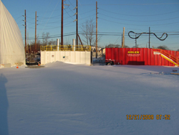
Air filtration unit and holding tank for excavation water
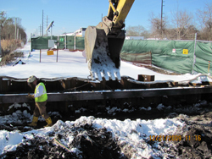
Installing support beams in excavation cells

